**Name: Kamal Agrahari Lab: DevOps**

**ID: VU4F2223028 TE | IT |A**

**Assignment – 1**

**Aim: Write Case Study on Bitbucket version control System**

**Introduction**

Bitbucket is a web-based version control repository hosting service that supports both Git and Mercurial systems. Founded in 2008 and acquired by Atlassian in 2010, Bitbucket has become essential for software development teams globally. Its robust features facilitate collaborative coding and project management, making it a popular platform among developers.

Beyond being a code repository, Bitbucket provides a comprehensive solution for managing software projects. It helps teams maintain code integrity and boost productivity through features like pull requests, issue tracking, and continuous integration and deployment (CI/CD). These capabilities are especially valuable in today’s fast-paced development environments.

Security and access control are also key focuses of Bitbucket, offering fine-grained permissions and branch restrictions to ensure only authorized personnel can make significant changes. This is particularly crucial for larger organizations or open-source projects, where maintaining code integrity is vital.

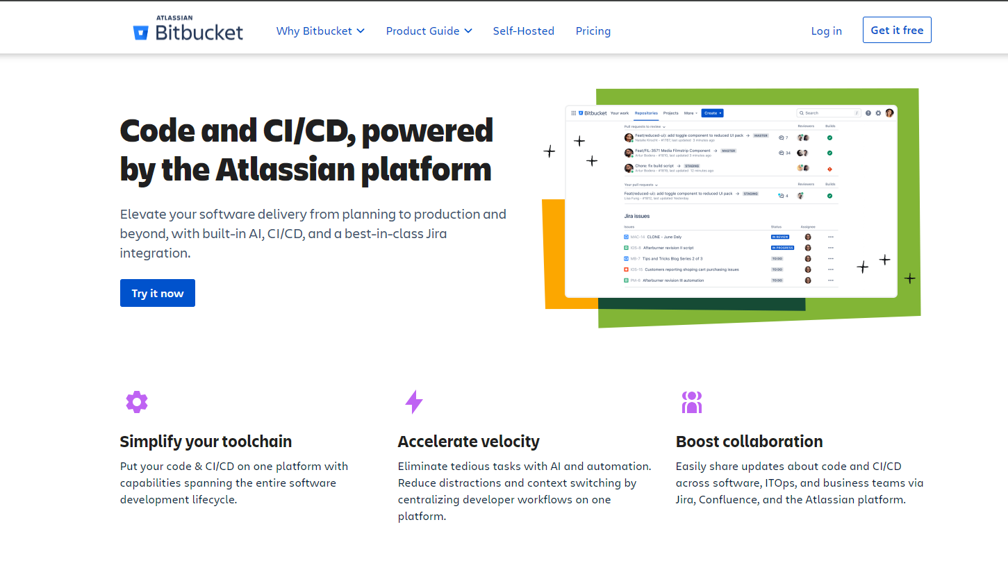

Moreover, Bitbucket seamlessly integrates with other Atlassian products such as Jira and Confluence, enabling a unified workflow for project management and documentation. This integration helps teams align their development efforts with project goals and user feedback, ensuring that the software meets the intended requirements and quality standards.

In this case study, we will explore the implementation details of Bitbucket, its important commands, benefits, and conclude with a reflection on its significance in the software development lifecycle. By understanding Bitbucket’s features and capabilities, teams can better leverage this powerful tool to enhance their collaborative efforts and streamline their development processes.

**ii) Implementation Detailss**

**Setting Up Bitbucket**

1. **Creating an Account**: Users need to sign up for a Bitbucket account, which can be free for small teams.

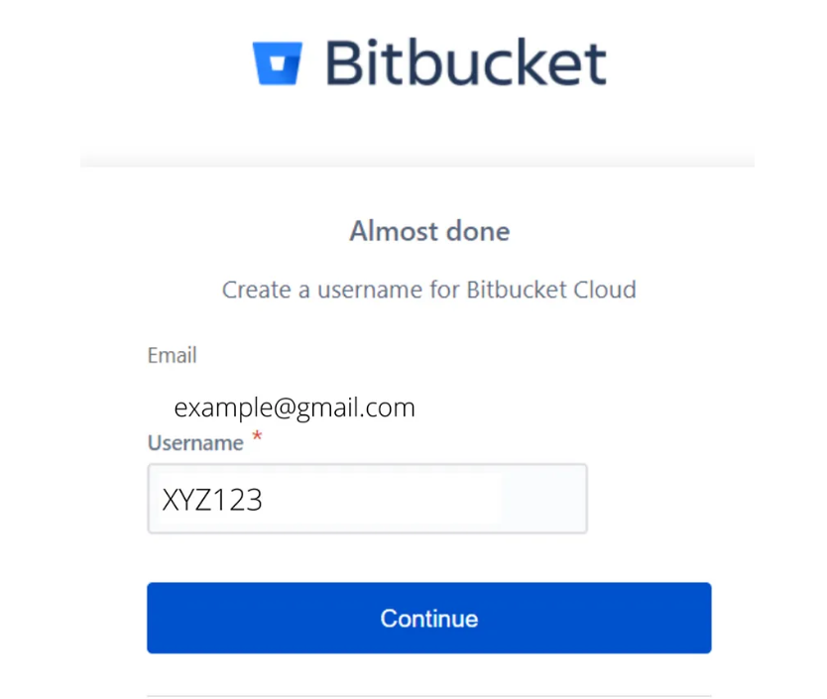

2. **Creating a Repository**: After logging in, users can create a new repository. This can be done via the Bitbucket interface by clicking on "Create Repository" and filling in the necessary details (repository name, access level, etc.).

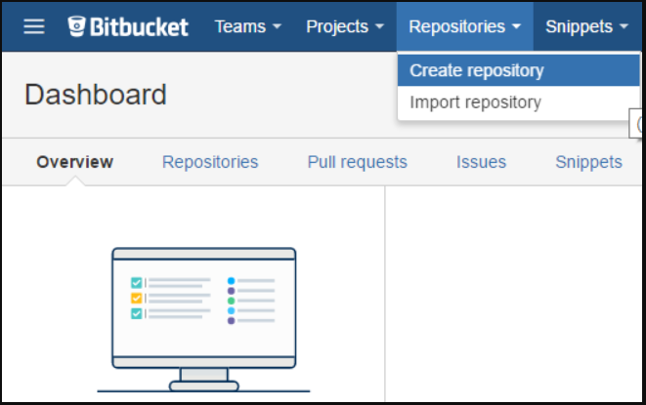

3. **Cloning the Repository**: Users can clone the repository locally using the command:

git clone https://<username>@bitbucket.org/<team>/<repository>.git

**Basic Workflow**

1. **Making Changes**: Users can make changes to their local files.

2. **Staging Changes**: Staged changes are added using:

git add <file>

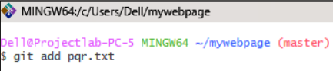

3. **Committing Changes**: Users commit their changes with a descriptive message:

git commit -m "Commit message"

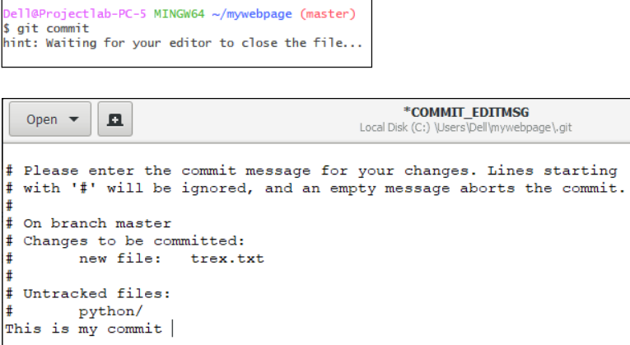

4. **Pushing Changes**: Finally, users push their changes to Bitbucket:

git push origin <branch>

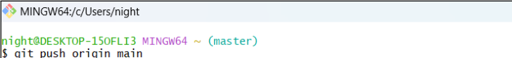

**Branching Strategy**

Bitbucket encourages a branching strategy to keep the codebase organized. Users can create branches for features, bug fixes, or experiments. This can be done with:

git checkout -b <branch-name>

**iii) Important Commands**

* **Cloning a Repository**:

git clone <repository-url>

* **Checking Status**:

git status

* **Adding Changes**:

git add <file>

* **Committing Changes**:

git commit -m "Your commit message"

* **Pushing Changes**:

git push origin <branch-name>

* **Pulling Updates**:

git pull origin <branch-name>

* **Creating a New Branch**:

git checkout -b <branch-name>

* **Merging Branches**:

git merge <branch-name>

**iv) Benefits**

1. **Collaboration**: Bitbucket allows multiple users to work on the same project simultaneously, facilitating collaboration through pull requests and code reviews.

2. **Version Control**: Users can track changes made to the code over time, enabling easy rollbacks and history tracking.

3. **Integration**: Bitbucket integrates seamlessly with other Atlassian products like Jira and Trello, enhancing project management and tracking.

4. **Branch Permissions**: Administrators can set branch permissions to control who can push changes to specific branches, ensuring code stability.

5. **Continuous Integration and Deployment**: Bitbucket provides built-in CI/CD capabilities, allowing teams to automate testing and deployment processes.

6. **Code Quality**: With features like pull requests and code reviews, teams can maintain high code quality and catch bugs early in the development process.

**v) Conclusion**

Bitbucket is a powerful version control system that enhances collaboration and productivity for software development teams. Its user-friendly interface, robust features, and integration capabilities make it a valuable tool for managing code repositories. By adopting Bitbucket, teams can effectively manage their projects, improve code quality, and streamline their development workflows. As software development continues to evolve, tools like Bitbucket play a crucial role in enabling teams to work efficiently and deliver high-quality software products.